

**SKILL JOURNAL**

Enrollment Number – 2019BTCS088 Year of Enrollment – 2019-2023

Name of the Student – YASH GUPTA

School of COMPUTER SCIENCE & INFORMATION TECHNOLOGY

Program – B. TECH

Specialization/ Branch – CS&IT

Semester – 4TH  Section – B2 Branch – CS&IT

Paper Code – IDSC 201 Name of Paper –Personal Enhancement Skills II (Self Awareness & Personal Development)

Faculty-In-Charge – DR. CHARUL JAIN MAM

CERTIFICATE

THE SKILL EXPERIMENTS

ENTERED IN THIS JOURNAL HAVE BEEN SATISFACTORY PERFORMED BY

ENROLLMENT NO - 2019BTCS088 MR.­­­­­­­­­­­­­ YASH GUPTA

STUDYING IN PROGRAM B. TECH BRANCH CS&IT IN

SCHOOL OF COMPUTER SCIENCE & INFORMATION TECHNOLOGY

DURING SEMESTER 4TH OF ACADEMIC YEAR 2020-2021

_______________________

( )

Date: _________________

INDEX

|  |  |  |  |  |
| --- | --- | --- | --- | --- |
| S.NO | Title of Skill Activity | Date of Allocation | Date of Submission | Sign of Faculty |
| 1 | Learnings from LEARNWISE (Wadhwani Foundation) | May 27th, 2021 | June 21st, 2021 |  |
|  |  |  |  |  |
|  |  |  |  |  |
|  |  |  |  |  |
|  |  |  |  |  |
|  |  |  |  |  |
|  |  |  |  |  |
|  |  |  |  |  |
|  |  |  |  |  |
|  |  |  |  |  |
|  |  |  |  |  |
|  |  |  |  |  |
|  |  |  |  |  |
|  |  |  |  |  |
|  |  |  |  |  |
|  |  |  |  |  |
|  |  |  |  |  |
|  |  |  |  |  |
|  |  |  |  |  |
|  |  |  |  |  |
|  |  |  |  |  |
|  |  |  |  |  |
|  |  |  |  |  |
|  |  |  |  |  |
|  |  |  |  |  |
|  |  |  |  |  |
|  |  |  |  |  |
|  |  |  |  |  |
|  |  |  |  |  |
|  |  |  |  |  |
|  |  |  |  |  |
|  |  |  |  |  |
|  |  |  |  |  |
|  |  |  |  |  |
|  |  |  |  |  |
|  |  |  |  |  |
|  |  |  |  |  |

SKILL ACTIVITIY NO: 1

(Learning Form LEARNWISE (Wadhwani Foundation))

Date: May 27th , 2021

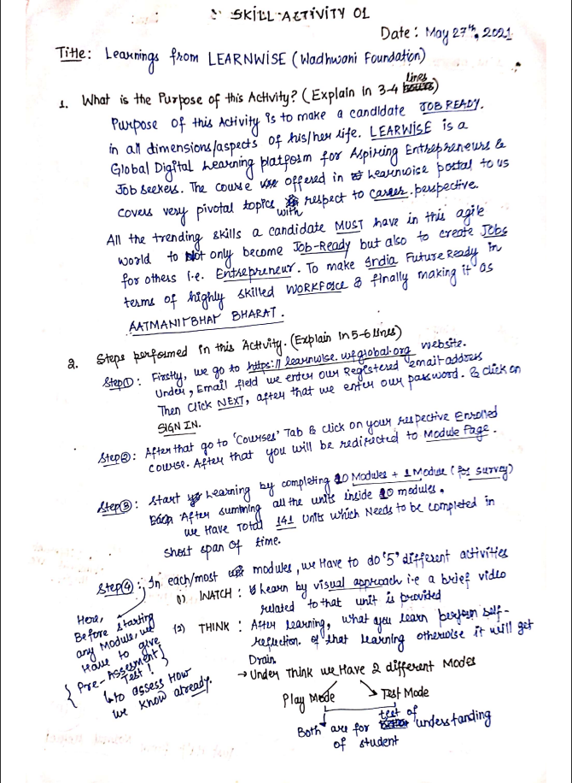

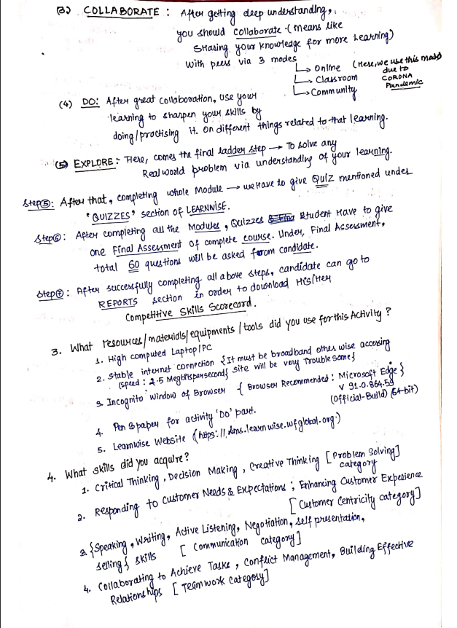

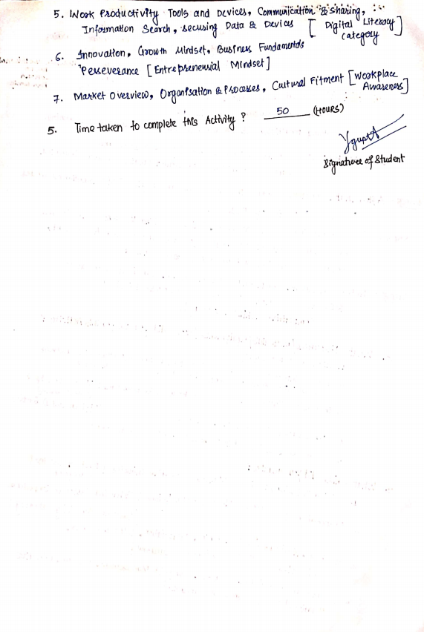

**(To be filled by Faculty)**

|  |  |  |
| --- | --- | --- |
| Sr. No. | Skill /Competencies | (Achieved / Not Achieved)  (Yes / No) |
| 1 | Writing effective post on LinkedIn | Yes |
| 2 | Interview Skills | Yes |
| 3 | Group Discussion Skills | Yes |

Remarks:

Total mark ___________________________out of 10.

Signature of Faculty

Date: _________________

**Details of the Activity**

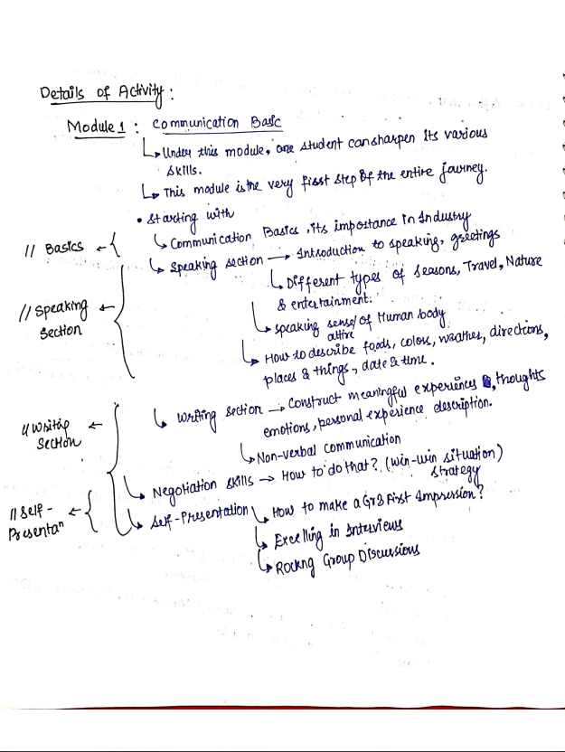

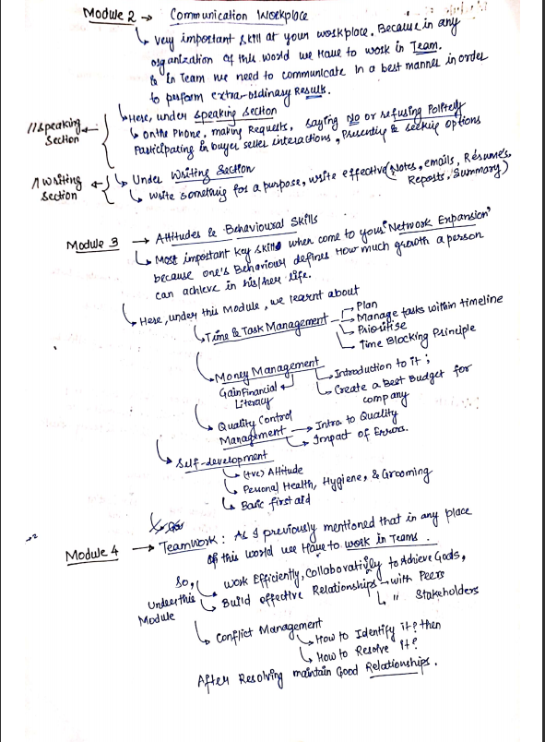

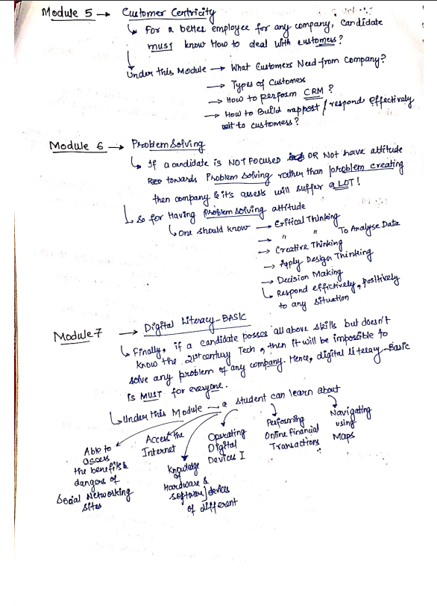

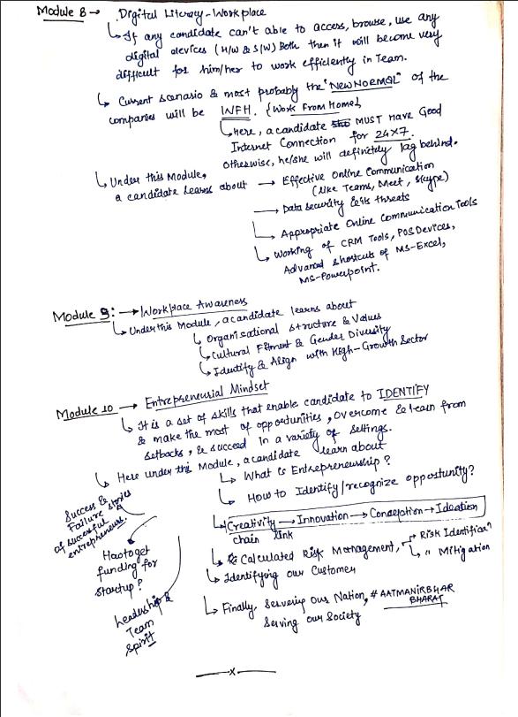

# FINAL ASSESSMENT REPORT:

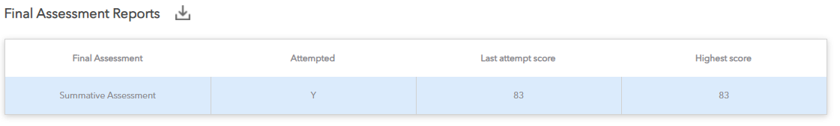

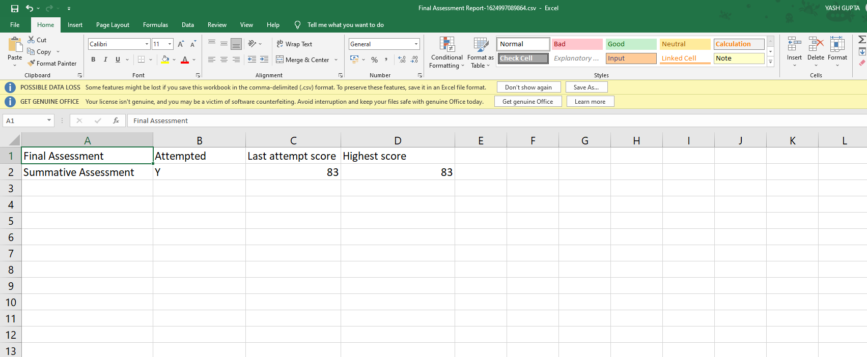

# comprehensive skills scorecard:

